- Setup Minikube in your local machine.

Install minikube on windows:
===========================
1) Install Docker on windows.
https://docs.docker.com/desktop/install/windows-install/
2) Install Oracle box on windows
https://adamtheautomator.com/install-virtualbox-on-windows-10/
3) Check system info in CMD
systeminfo
4) Install Minikube using powershell
https://minikube.sigs.k8s.io/docs/start/
5) Set the minikube path to environmental varaible
export PATH=$PATH:/c/minikube
6) Restart powershell and start minikube
minikube start

Step 1: Verified Docker and oraclebox Installation
Checked whether Docker was installed and running.

docker --version

Confirmed Docker version was available.
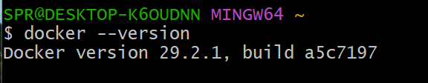

Oraclebox :

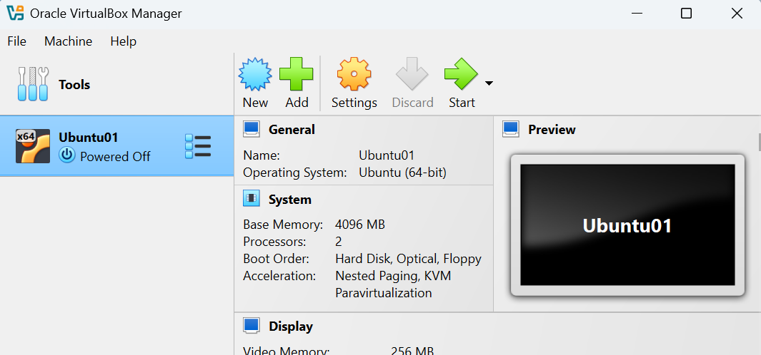

Step 2: Check system info in CMD

Systeminfo
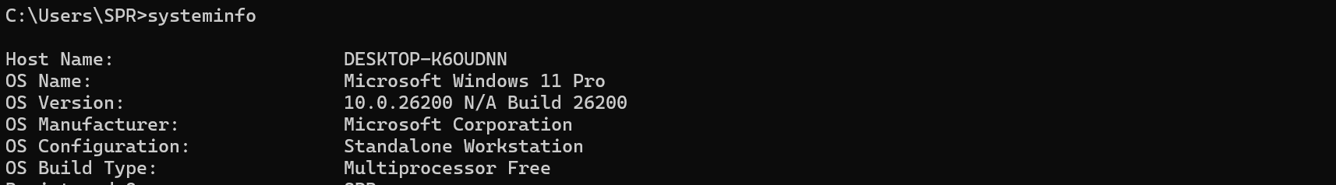

We can and should see A hypervisor has been detected.

Step 3: Opened Minikube Official Documentation

Accessed Minikube installation guide via browser.
https://minikube.sigs.k8s.io/docs/start/

- using PowerShell, run below commands and close powershell after executing commands

New-Item -Path 'c:\' -Name 'minikube' -ItemType Directory -Force
$ProgressPreference = 'SilentlyContinue'; Invoke-WebRequest -OutFile 'c:\minikube\minikube.exe' -Uri 'https://github.com/kubernetes/minikube/releases/latest/download/minikube-windows-amd64.exe' -UseBasicParsing

$oldPath = [Environment]::GetEnvironmentVariable('Path', [EnvironmentVariableTarget]::Machine)
if ($oldPath.Split(';') -inotcontains 'C:\minikube'){
[Environment]::SetEnvironmentVariable('Path', $('{0};C:\minikube' -f $oldPath), [EnvironmentVariableTarget]::Machine)
}

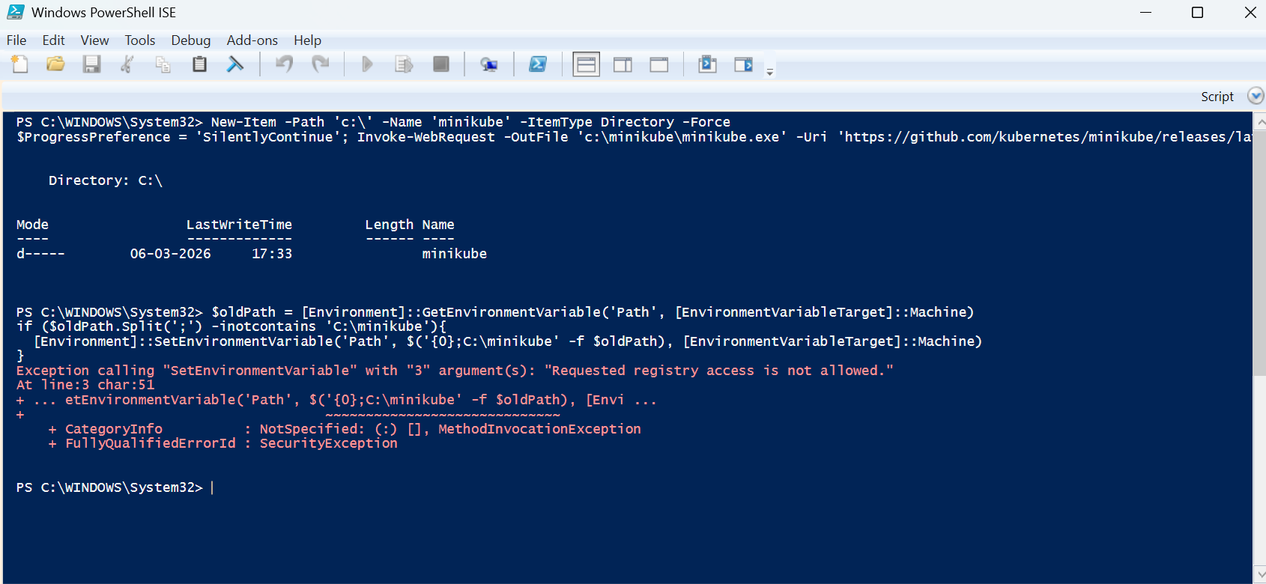

close the powershell.

Step 4: Set the minikube path to environmental varaible

Go to edit system environment variables --> click on environment variables -->

Under system variables , click path --> edit --> select new --> add minikube path
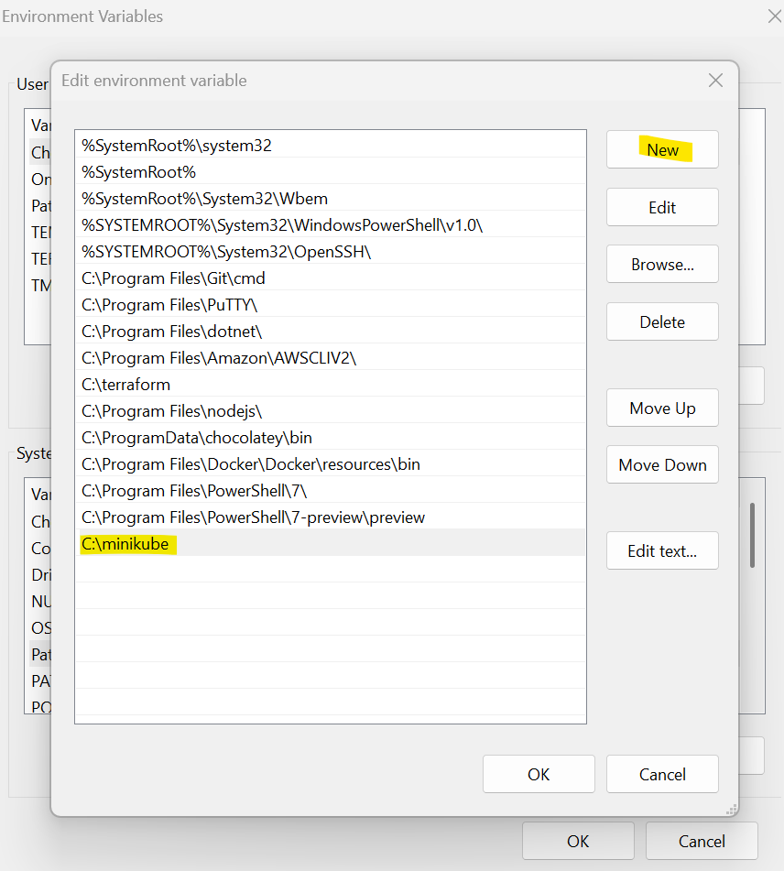

Step 5: start the minikube

Open new terminal of any gitbash , vs.studio , or powershell
And verify docker running on local machine by [ docker --version and docker ps ]

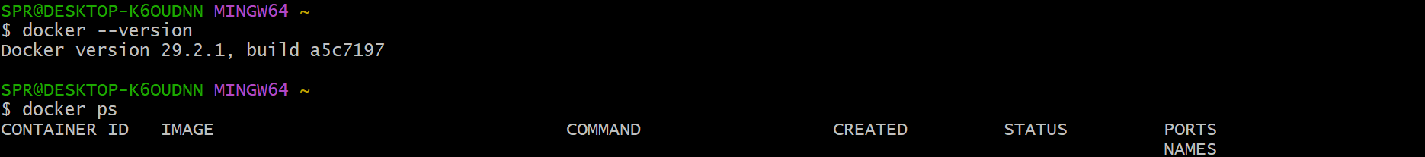

To check minikube version : minikube version
To start minikube : minikube start
To check minikube ip use : minikube ip
To ssh to minikube : minikube ssh
To connect or check the pods : kubctl get pods
To see minikube on dashboard : minikube dashboard

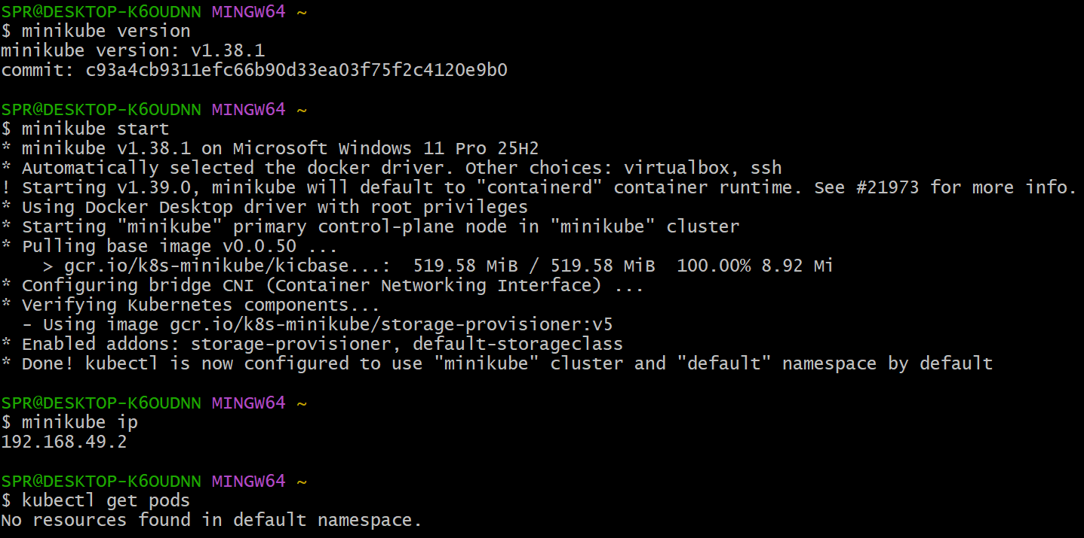
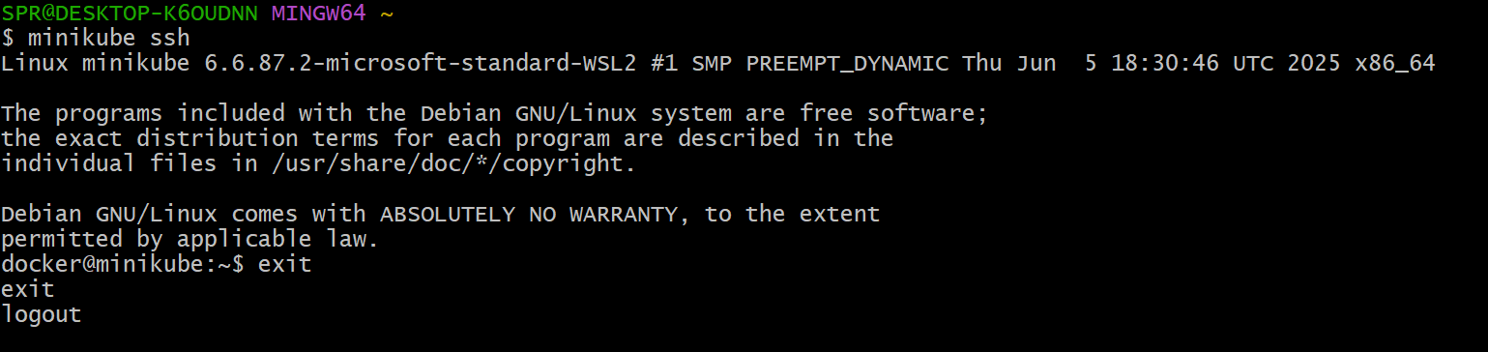

- Setup k8s master and two worker nodes on ubuntu.

Steps Performed – Kubernetes Cluster Setup

Step 1: Launched EC2 Instances
Created 3 EC2 instances via AWS Console.
Configuration:
• Selected Ubuntu AMI
• Configured instance type
• Added Name tags
Instances created:
• K8s-Master
• K8s-Worker-01
• K8s-Worker-02
Verified instance state → Running

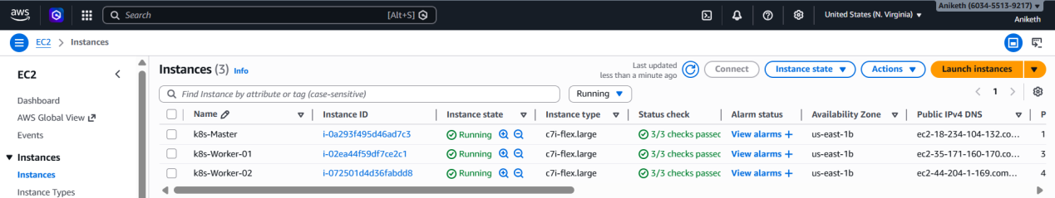

Step 2: Connected to 3 ec2 Instances via SSH and Disabled swap memory

Executed on ALL 3 nodes:

sudo swapoff -a

free -h

Confirmed swap memory → 0B

Made swap persistent:

sudo sed -i '/ swap / s/^/#/' /etc/fstab

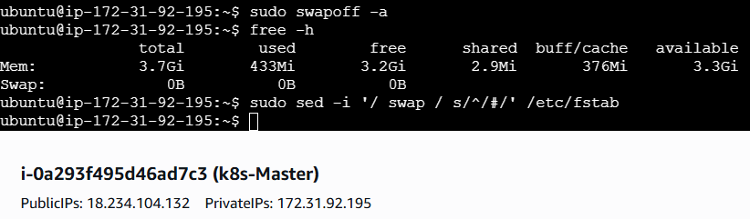
--------------------------------------------------------------------------------------------------------------------------------------
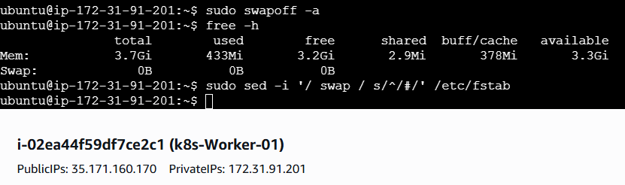
---------------------------------------------------------------------------------------------------------------------------------------
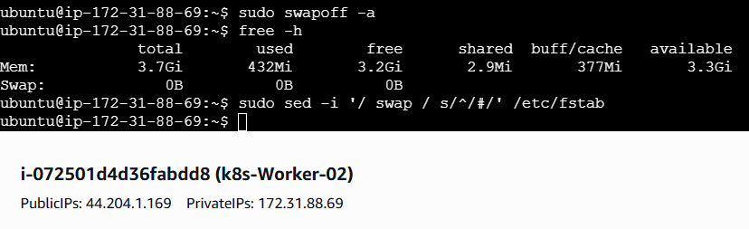
Step 4: Configured Hostnames

Assigned hostnames for identification.
Master Node:
sudo hostnamectl set-hostname k8s-master

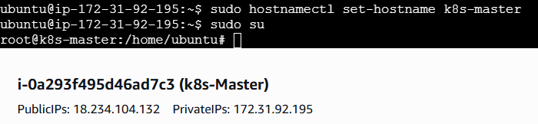

Worker Nodes:

sudo hostnamectl set-hostname k8s-worker-01

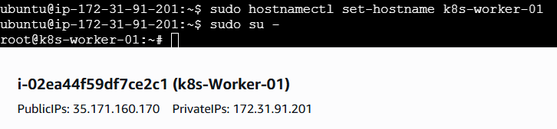
-----------------------------------------------------------------------------------------------------------------------

sudo hostnamectl set-hostname k8s-worker-02

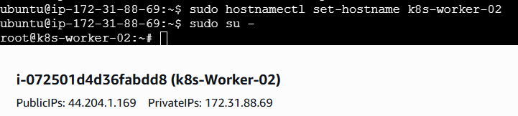

Step 5: Updated Hosts File

Configured internal DNS resolution.

Executed on ALL nodes:

sudo vi /etc/hosts
Added:
<Master-PrivateIP> master
<Worker1-PrivateIP> worker-01
<Worker2-PrivateIP> worker-02

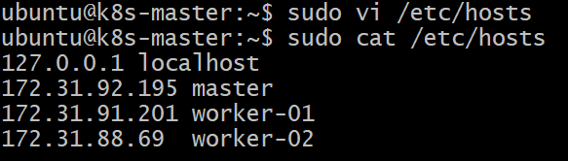
-----------------------------------------------------------------------------------------------
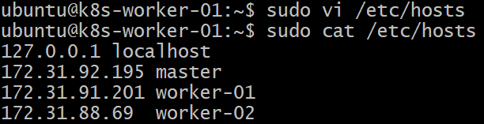
----------------------------------------------------------------------------------------------------
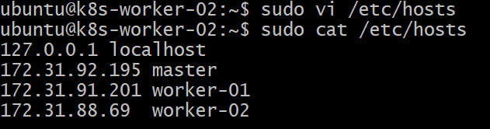
Step 6: Verified Node Connectivity
Validated inter-node communication:
ping master

ping worker-01

ping worker-02

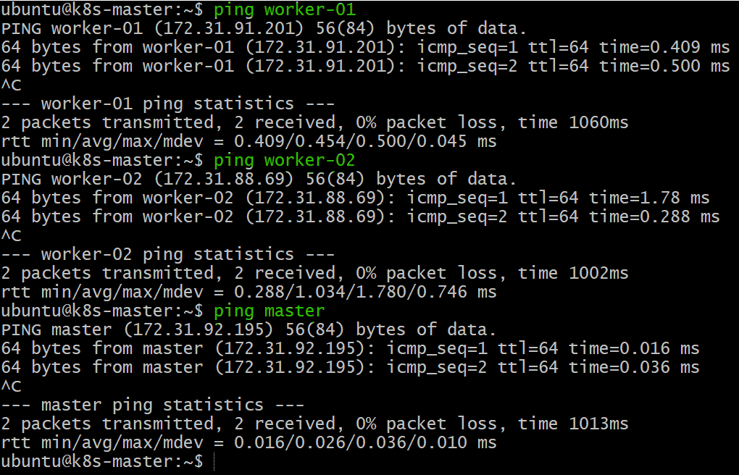

Confirmed network connectivity between nodes.

Step 7: Install docker based on Operating system in 3 instances

Commands to install docker in ubuntu os:

sudo apt install apt-transport-https ca-certificates curl software-properties-common -y

curl -fsSL https://download.docker.com/linux/ubuntu/gpg | sudo gpg --dearmor -o /usr/share/keyrings/docker-archive-keyring.gpg

echo "deb [arch=$(dpkg --print-architecture) signed-by=/usr/share/keyrings/docker-archive-keyring.gpg] https://download.docker.com/linux/ubuntu $(lsb_release -cs) stable" | sudo tee /etc/apt/sources.list.d/docker.list > /dev/null

sudo apt update -y

sudo apt install docker-ce docker-ce-cli containerd.io docker-buildx-plugin docker-compose-plugin -y

docker --version

sudo systemctl start docker

sudo systemctl enable docker

Step 8: Install tools kubeadm , kubectl , kublet on 3 instances with reference to

https://kubernetes.io/docs/setup/production-environment/tools/kubeadm/install-kubeadm/

Executed on ALL nodes:

sudo apt-get update

sudo apt-get install -y apt-transport-https ca-certificates curl gpg

curl -fsSL https://pkgs.k8s.io/core:/stable:/v1.35/deb/Release.key | sudo gpg --dearmor -o /etc/apt/keyrings/kubernetes-apt-keyring.gpg

echo 'deb [signed-by=/etc/apt/keyrings/kubernetes-apt-keyring.gpg] https://pkgs.k8s.io/core:/stable:/v1.35/deb/ /' | sudo tee /etc/apt/sources.list.d/kubernetes.list

sudo apt-get update

sudo apt-get install -y kubelet kubeadm kubectl

sudo apt-mark hold kubelet kubeadm kubectl

sudo systemctl enable --now kubelet

Step 9: Installed Container Runtime (containerd)
Executed on ALL nodes:

sudo apt install -y containerd

sudo mkdir -p /etc/containerd

containerd config default | sudo tee /etc/containerd/config.toml

sudo sed -i 's/SystemdCgroup = false/SystemdCgroup = true/' /etc/containerd/config.toml

cat <<EOF | sudo tee /etc/sysctl.d/k8s.conf
net.bridge.bridge-nf-call-ip6tables = 1
net.bridge.bridge-nf-call-iptables = 1
net.ipv4.ip_forward = 1
EOF

sysctl --system

sudo systemctl restart containerd

sudo systemctl enable containerd

systemctl restart kubelet

kubeadm reset -f

Step 10: setup networking and configure master .

TO configure master we need to initialize with CIDR
**Execute only on master ** :

sudo kubeadm config images pull

kubeadm init --pod-network-cidr=10.244.0.0/16

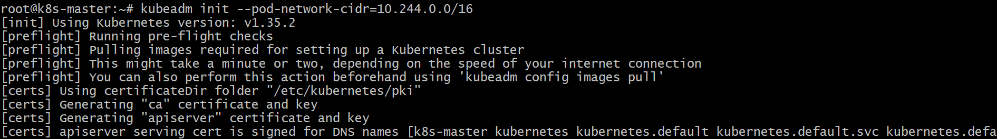
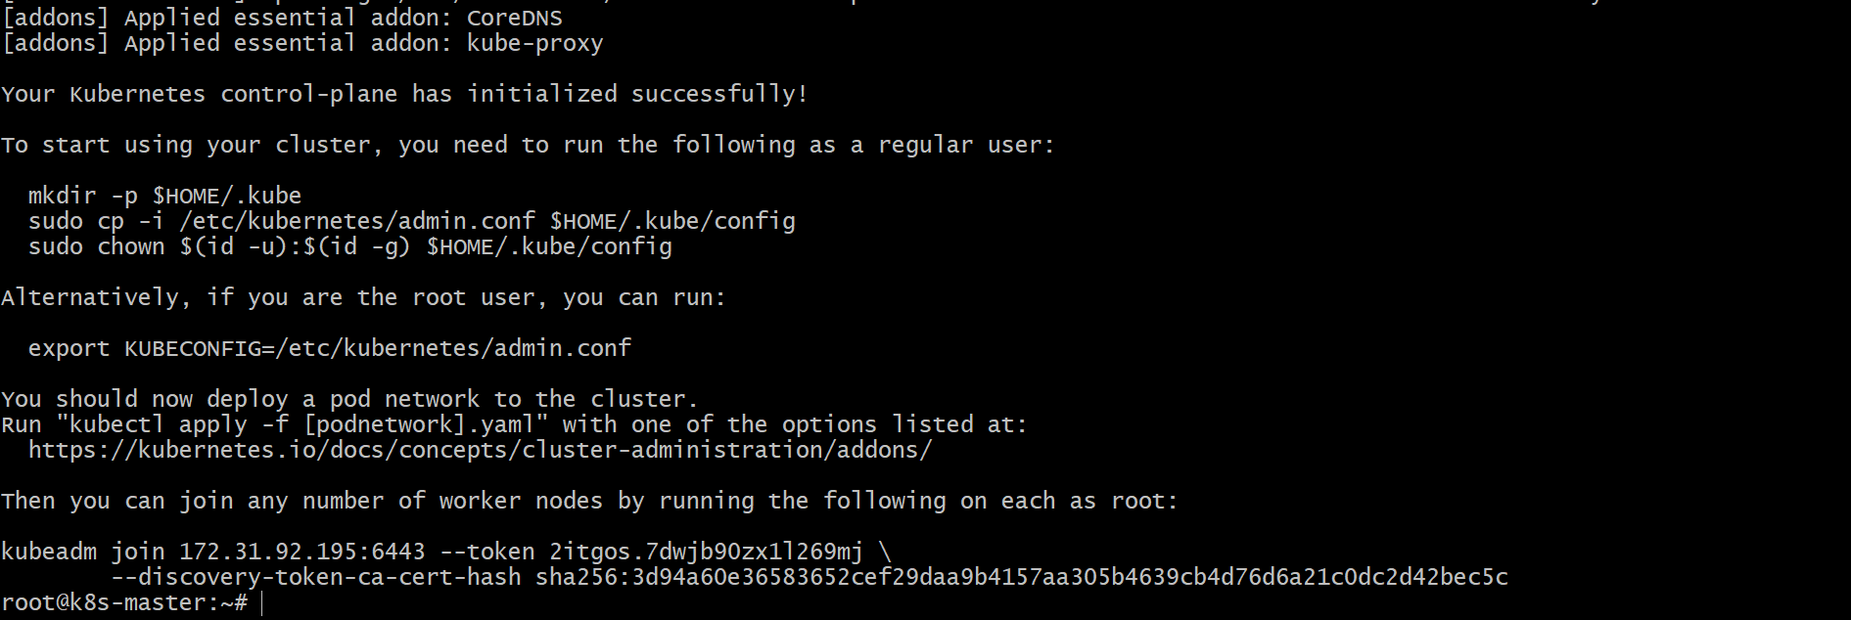

Step 11: To start using your cluster, you need to run the following on master

mkdir -p $HOME/.kube

sudo cp -i /etc/kubernetes/admin.conf $HOME/.kube/config

sudo chown $(id -u):$(id -g) $HOME/.kube/config

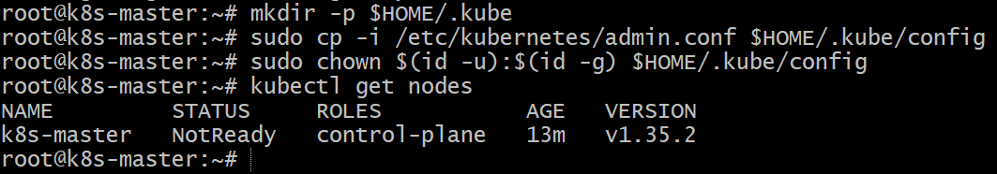

Step 12: from the output step 10

you can join any number of worker nodes by running the following on each as root:

kubeadm join 172.31.92.195:6443 --token 2itgos.7dwjb90zx1l269mj \ --discovery-token-ca-cert-hash sha256:3d94a60e36583652cef29daa9b4157aa305b4639cb4d76d6a21c0dc2d42bec5c

Execute on both worker nodes

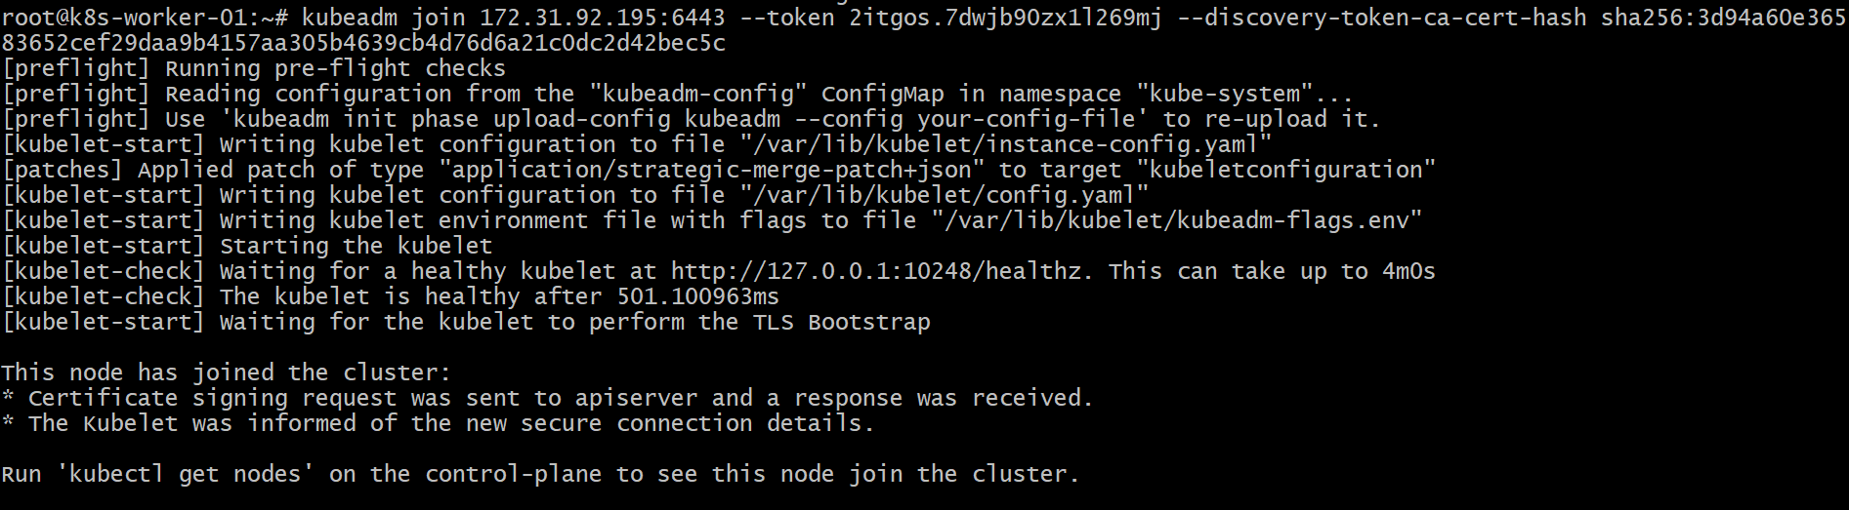
---------------------------------------------------------------------------------------------------------------------------------------
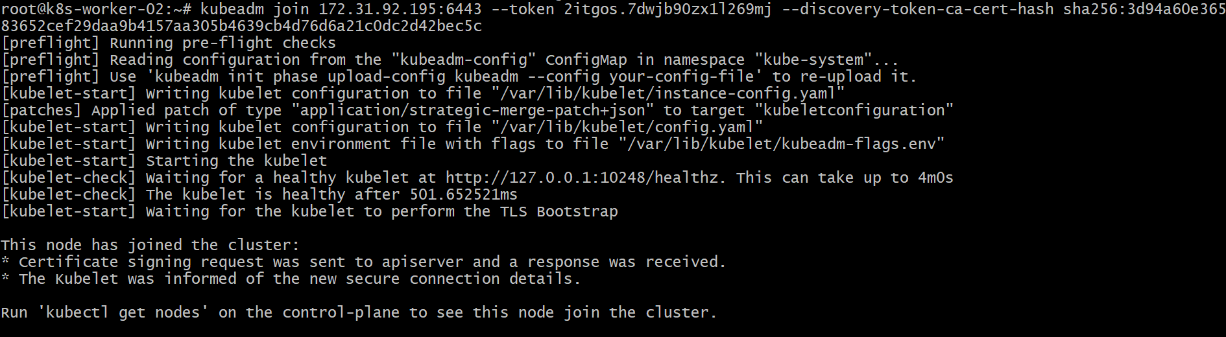

Step 13: Verified Master Node
kubectl get nodes

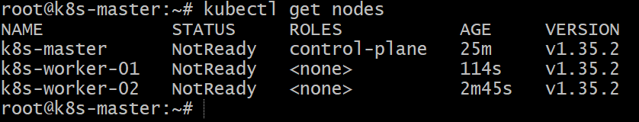

Step 14: Install Flannel to make status as ready on master

kubectl apply -f https://raw.githubusercontent.com/flannel-io/flannel/master/Documentation/kube-flannel.yml

Kubectl get nodes

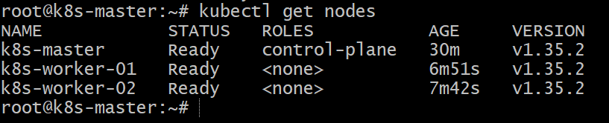

- Run one nginx pod.

Step 1: Created NGINX Pod
Executed the following command on the master node:

kubectl run nginx --image=nginx

Outcome:
• Kubernetes created a pod named nginx
• Pod creation confirmed by system response
Step 2: Verified Pod Status

kubectl get pods

Kubectl get pods -o wide

Observed:
• Pod name → nginx
• Ready status → 1/1
• Current state → Running
• Restart count → 0

